EV CHARGING DEMAND & OPERATIONS ANALYTICS
ABSTRACT
The EV Charging Demand & Operations Analytics project analyses electric vehicle charging-session data to understand charging demand and station performance. The dataset contains 1,000 charging records with information such as station, charger type, vehicle type, energy consumption, charging duration, and waiting time. The data is prepared and analysed using MySQL and SQL to calculate important operational metrics. Power BI is used to create an interactive dashboard with KPI cards, charts, slicers, and station-performance analysis. The dashboard helps identify charging-demand patterns, compare stations, and understand operational performance. The project provides useful insights that can support better charging-station management and future infrastructure planning.
INTRODUCTION
Electric vehicles are becoming increasingly important in modern transportation, creating a growing need for efficient charging infrastructure. Charging stations generate valuable operational data through every charging session. This data can be used to understand customer demand, energy consumption, charging duration, waiting time, and station performance.
In this project, EV charging data is analysed using SQL and visualized using Power BI. The main purpose is to convert raw charging data into clear information that can help understand charging operations, identify demand patterns, compare station performance, and support data-driven decisions.
PROBLEM STATEMENT
Managing a large number of EV charging sessions manually makes it difficult to understand charging demand and station performance. It can be challenging to identify high-demand stations, compare energy consumption, monitor charging duration, and analyse waiting time.
Without proper analysis and visualization, important operational patterns may be missed. Therefore, this project develops a data analytics solution using SQL and Power BI to analyse EV charging operations and present the results through an interactive dashboard.
EXISTING SYSTEM
In the existing approach, EV charging information may be maintained mainly as individual transaction records or basic reports. Such records provide raw information but do not easily show overall charging trends or station-level performance.
Manual analysis also makes comparison between stations and identification of high-demand periods difficult. There is limited integration between data analysis and interactive visualization, making it harder for operators to obtain quick and meaningful operational insights.
PROPOSED SYSTEM
The proposed system uses MySQL, SQL, and Power BI to analyse EV charging operations. The charging dataset is first cleaned and prepared, then imported into MySQL, where SQL queries are used to calculate important metrics and analyse different charging categories.
The processed data is connected to Power BI to create an interactive dashboard containing KPI cards, charts, tables, and slicers. The dashboard provides three major views: Executive Overview, Charging Demand Analysis, and Station Performance.
This system converts raw charging records into useful information for operational monitoring, station comparison, and data-driven decision-making.
PROJECT WORKFLOW
EV Dataset → Data Preparation → MySQL → SQL Analysis → Power BI → Dashboard → Insights
OBJECTIVES
The main objectives of the project are:
To analyse EV charging-session data and understand overall charging demand and operational patterns.
To calculate important KPIs such as total charging sessions, energy consumed, average charging duration, average waiting time, and average energy per session.
To compare charging stations based on charging sessions, energy consumption, charging duration, and waiting time.
To analyse charging patterns based on charger type, vehicle type, and other available categories.
To develop an interactive Power BI dashboard for monitoring charging demand and station performance.
To generate useful insights and recommendations for improving EV charging operations.

DATASET DESCRIPTION
The project uses an EV charging dataset containing 1,000 charging-session records. The dataset includes important information related to charging sessions, stations, vehicles, energy consumption, charging duration, waiting time, payment details, and session status.
The major fields used in the dataset include:
Column | Description
Session_ID | Unique identifier for each charging session
Station_ID | Identifier of the charging station
Session_Date | Date of the charging session
Charger_Type | Type of charger used
Vehicle_Type | Type of electric vehicle
Energy_Consumed | Energy consumed during the charging session
Charging_Duration | Duration of the charging session
Waiting_Time | Time spent waiting before charging
Payment_Method | Payment method used for the session
Session_Status | Status of the charging session
The dataset was checked and prepared before being imported into MySQL for SQL analysis and Power BI visualization.
DATA PREPARATION
The dataset was prepared before performing the analysis to improve data quality and consistency.
The following data-preparation activities were performed:
- Checked the dataset structure and number of records.
- Checked for missing values.
- Checked for duplicate records.
- Verified the consistency of categorical values.
- Checked numerical fields for suitable values.
- Verified the appropriate data types for analysis.
- Prepared the dataset for storage in MySQL.
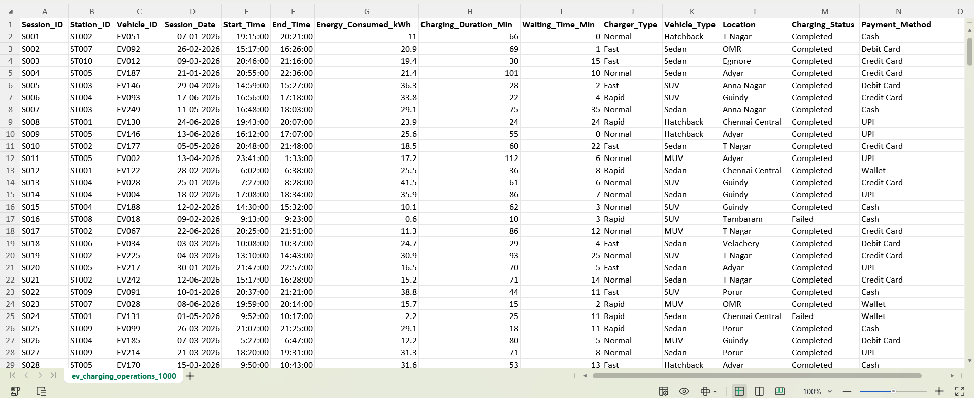
Figure 1: EV Charging Dataset Used for Analysis
After completing the required cleaning and validation, the prepared dataset was used for MySQL analysis and Power BI dashboard development.
MYSQL DATABASE IMPLEMENTATION
The prepared EV charging dataset was stored in a MySQL database named ev_charging_analytics.
A table named charging_sessions was created to store the charging-session records.
The database provides a structured environment for storing and analysing the EV charging data. SQL queries were executed on the charging_sessions table to calculate operational metrics and identify charging-demand patterns.
Database Workflow
Prepared EV Dataset → MySQL Database → charging_sessions Table → SQL Queries → Analysis Results
SQL ANALYSIS
SQL was used to analyse the EV charging dataset stored in MySQL.
SQL operations such as COUNT, SUM, AVG, GROUP BY, WHERE, ORDER BY, CASE, subqueries, and other aggregation and filtering operations were used to calculate important charging metrics.
The analysis covered:
- Total charging sessions
- Total energy consumption
- Average charging duration
- Average waiting time
- Average energy consumed per session
- Charging sessions by charger type
- Charging sessions by vehicle type
- Station-level charging sessions
- Energy consumption by station
- Charging duration by station
- Waiting time by station
- Session-status analysis
- Identification of higher- and lower-demand stations
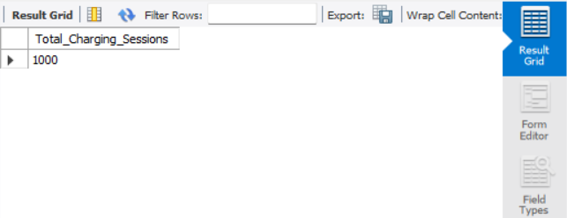
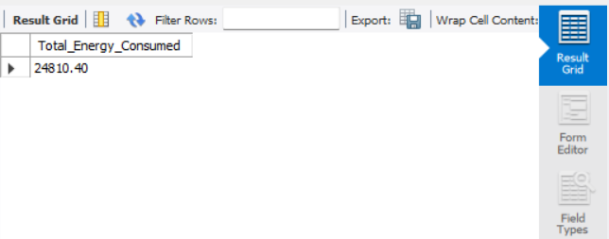
Figure 2: SQL Analysis of Total Charging Sessions and Energy Consumption
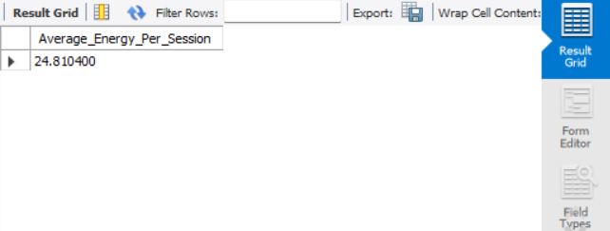
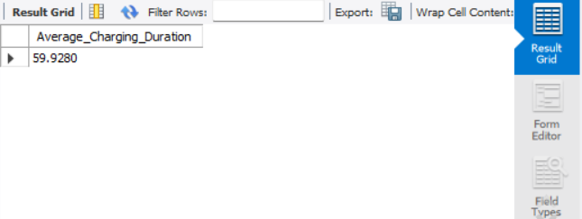
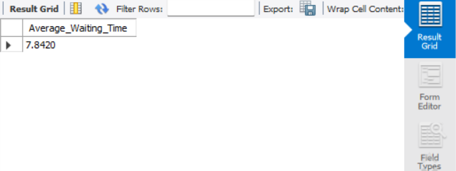
Figure 3: SQL Analysis of Operational Charging KPIs
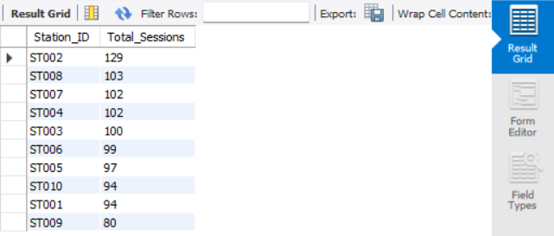
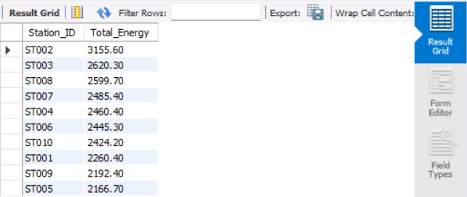
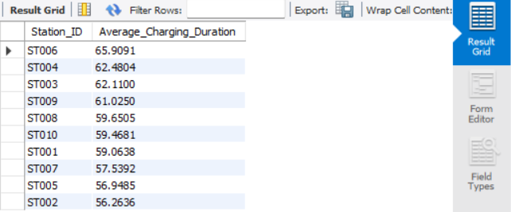
Figure 4: Station-Level Charging Performance Analysis using SQL
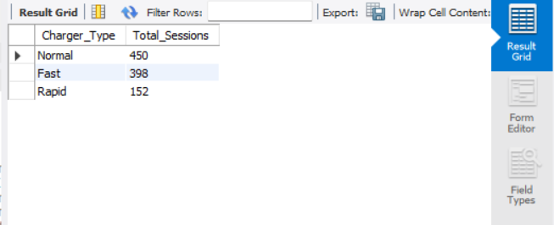
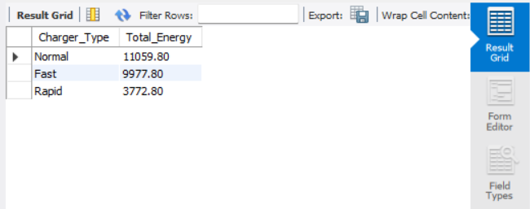
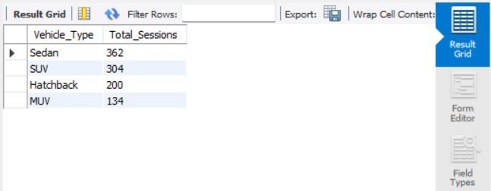
Figure 5: Charging Analysis by Charger Type and Vehicle Type
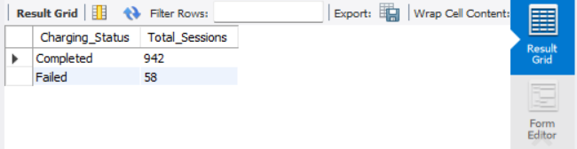
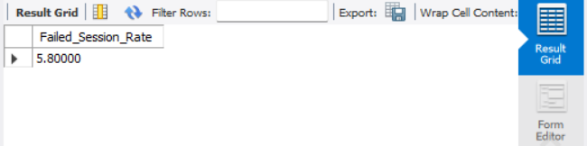
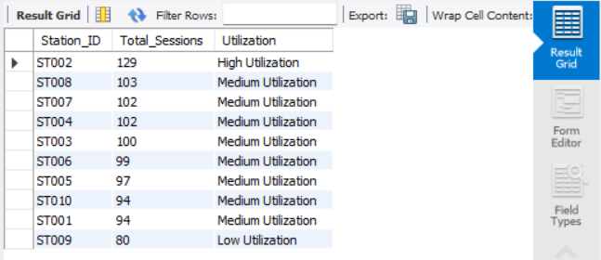
Figure 6: Charging Status and Station Utilization Analysis using SQL
The SQL analysis results were used as the foundation for the Power BI dashboard.
KEY PERFORMANCE INDICATORS (KPI) ANALYSIS
The Power BI dashboard uses important KPIs to provide a quick overview of EV charging operations.
The main KPIs are:
- Total Charging Sessions
- Total Energy Consumed
- Average Charging Duration
- Average Waiting Time
- Average Energy per Session
These KPIs help users understand the overall scale of charging activity and the operational characteristics of the charging network.

KPI Values
Enter the exact values from your final Power BI dashboard:
KPI | Value
Total Charging Sessions | 1K
Total Energy Consumed | 24.81K
Average Charging Duration | 59.93
Average Waiting Time | 7.84
Average Energy per Session | 24.81
CHARGING DEMAND ANALYSIS
Charging-demand analysis was performed to understand how EV charging activity varies across different stations, charger types, vehicle types, and time periods.
The analysis helps identify stations with higher charging-session volumes and understand differences in energy consumption.
The dashboard provides visualizations for:
- Charging sessions by station
- Charging sessions by charger type
- Charging sessions by vehicle type
- Charging sessions by time period
- Energy consumption by station
- Energy consumption by charger type
- Waiting time analysis
These visualizations help identify charging-demand patterns and areas that may require closer operational monitoring.
STATION PERFORMANCE ANALYSIS
Station performance analysis was performed to compare individual charging stations based on available operational metrics.
The analysis considers:
- Number of charging sessions
- Total energy consumed
- Average charging duration
- Average waiting time
- Session status
Stations with higher session volumes indicate relatively higher charging demand. Stations with higher waiting times may require further investigation to understand possible congestion or charger availability issues.
Comparing these metrics provides a clearer understanding of differences in charging-station performance.
POWER BI DASHBOARD
Power BI was used to convert the analysed EV charging data into an interactive dashboard.
The dashboard contains KPI cards, charts, tables, and slicers for analysing charging operations.
The Power BI report is divided into three main pages:
Page 1 - Executive Overview
This page provides an overall summary of the EV charging network.
It includes:
- Total Charging Sessions
- Total Energy Consumed
- Average Charging Duration
- Average Waiting Time
- Average Energy per Session
- Charging sessions by station
- Energy consumption overview
- Charger-type analysis
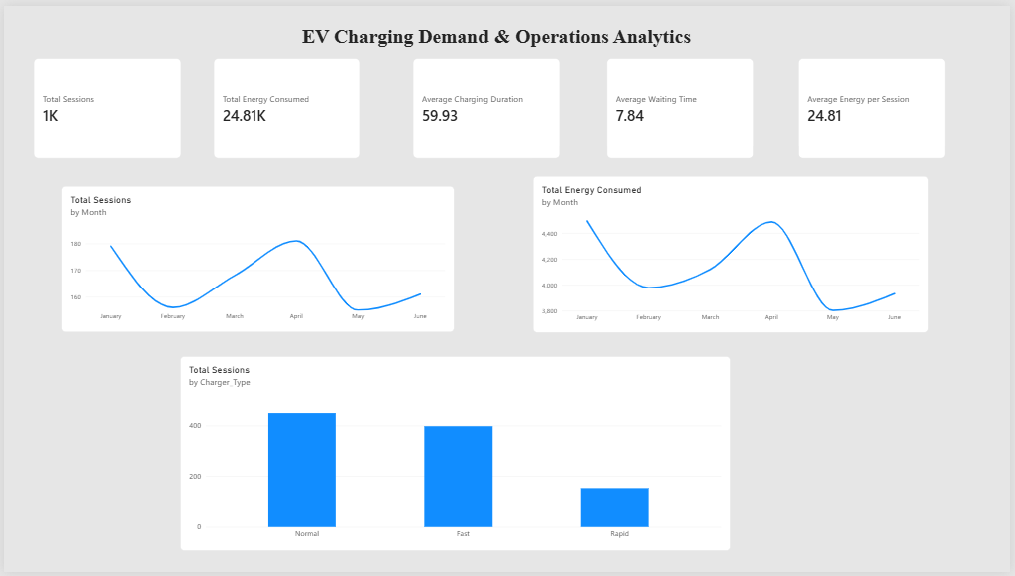
Figure 7: Power BI - Executive Overview Dashboard

Page 2 - Charging Demand Analysis
This page focuses on charging-demand patterns.
- It includes:
- Charging sessions by station
- Charging sessions by time period
- Charging sessions by charger type
- Charging sessions by vehicle type
- Energy consumption analysis
- Waiting-time analysis
- Interactive filters
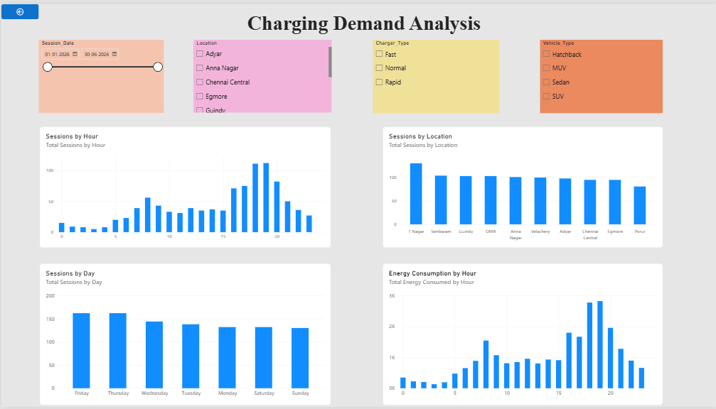
Figure 8: Power BI - Charging Demand Analysis Dashboard
Page 3 - Station Performance
This page focuses on station-level comparison.
It includes:
- Station-wise charging sessions
- Station-wise energy consumption
- Average charging duration
- Average waiting time
- Session status
- Station details table
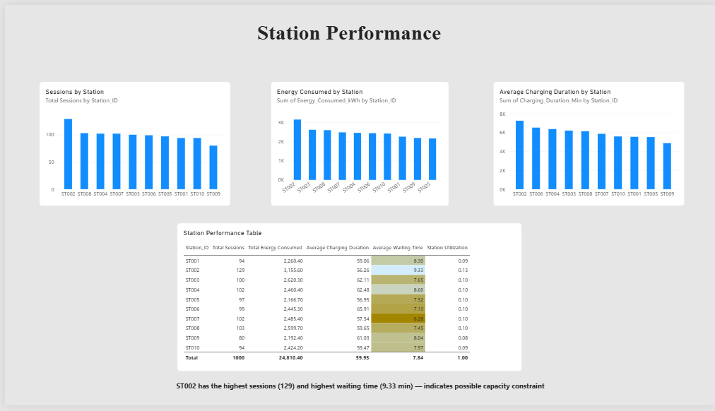
Figure 9: Power BI - Station Performance Dashboard
DASHBOARD FEATURES
The Power BI dashboard provides several interactive features for easier analysis.
KPI Cards
KPI cards display the major charging-network metrics such as total sessions, total energy consumed, average charging duration, average waiting time, and average energy per session.
Charts
Charts are used to compare stations, charger types, vehicle types, energy consumption, and charging-demand patterns.
Slicers
Interactive slicers allow users to filter the dashboard based on available categories such as:
- Session Date
- Station
- Charger Type
- Vehicle Type
- Session Status
- Station Analysis
Users can compare charging stations based on their available operational metrics.

Interactive Dashboard
The dashboard allows users to explore different aspects of EV charging operations without manually analysing individual records.
BUSINESS INSIGHTS
The dashboard analysis helps identify differences in charging demand across stations and categories.
Stations with higher session volumes indicate relatively higher charging demand and may require closer monitoring. Energy consumption analysis helps identify stations or charger categories with higher usage.
Charging duration and waiting-time analysis can indicate possible operational pressure and areas requiring further investigation. Comparing these measures provides an overall understanding of charging-station performance.
Final Insights to Add After Dashboard Completion
After completing the dashboard, add your actual results in this format:
- Highest-demand station: [Station ID] with [value] charging sessions.
- Lowest-demand station: [Station ID] with [value] charging sessions.
- Highest energy-consuming station: [Station ID] with [value] energy consumed.
- Highest average waiting time: [Station ID] with [value] minutes.
- Highest average charging duration: [Station ID] with [value] minutes.
- Most-used charger type: [Charger Type] with [value] sessions.
- Most-used vehicle type: [Vehicle Type] with [value] sessions.
- Use only the actual values shown in your SQL results or Power BI dashboard.
BUSINESS RECOMMENDATIONS
Based on the analysis, the following recommendations can be considered:
1. Monitor High-Demand Stations
High-demand stations should be monitored regularly, and additional charging capacity can be considered where demand remains consistently high.
2. Reduce Waiting Time
Stations with higher waiting times should be investigated to identify possible congestion or insufficient charger availability.
3. Improve Charging Operations
Charging demand, energy consumption, charging duration, and waiting time should be monitored regularly to improve operational efficiency.
4. Optimize Station Management
Station-level performance should be compared regularly to identify areas requiring operational improvement.
5. Support Infrastructure Planning
Historical charging-demand data can be used to support future charging-infrastructure and capacity-planning decisions.
FUTURE SCOPE
The project can be extended by integrating real-time EV charging data and IoT sensors for live monitoring of charger availability, energy consumption, and charging status.
Machine-learning techniques can be introduced for charging-demand forecasting and peak-hour prediction.
- Future versions can also include:
- Predictive maintenance
- Automated alerts
- Real-time charger availability
- Charging-demand forecasting
- Peak-hour prediction
- Mobile-based monitoring
- Real-time operational dashboards
These extensions can help create a more intelligent and responsive EV charging management system.
CONCLUSION
The EV Charging Demand & Operations Analytics project demonstrates how MySQL, SQL, and Power BI can be used to analyse EV charging operations effectively. The project transforms 1,000 charging-session records into meaningful KPIs, visualizations, and station-level performance information. SQL provides a structured approach for analysing charging data, while Power BI provides an interactive way to understand charging demand, energy consumption, charging duration, waiting time, and station performance. The developed dashboard can support data-driven operational decisions and help identify areas requiring further investigation. The project can be further enhanced through real-time monitoring, IoT integration, predictive analytics, and charging-demand forecasting.

REFERENCES
• MySQL Documentation - for MySQL database and SQL queries.
• Microsoft Power BI Documentation - for Power BI dashboards, visuals, and slicers.
• Microsoft DAX Documentation - for the KPI measures used in Power BI.
• EV Charging Operations Dataset - for the dataset used in your project.

